1. check responsive

2. check sign up/ sign in page bottom section

3. sign up/sign in page slideshow must be run automatically

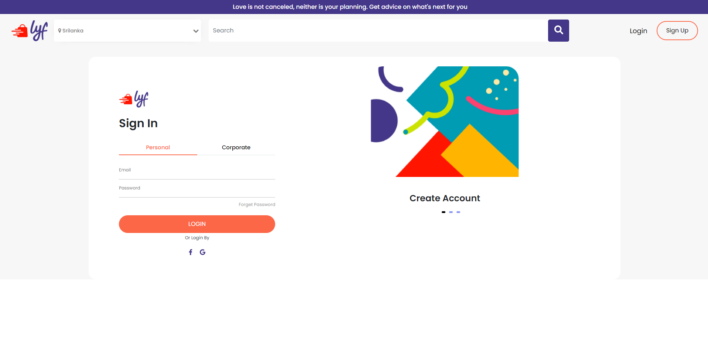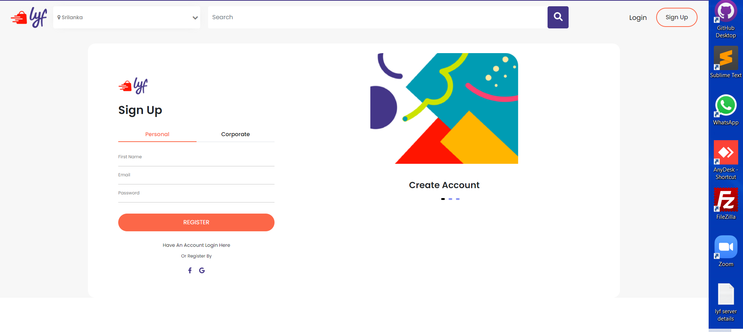

4. navbar (after login) -> include the notification count icon.



5. homepage ads section -> recent ads section is missing

6. homepage footer -> scroll bar located in footer section (bottom of the page)

7. chat icon / notification icon -> views are missing (to see what chats or what notification is received. Below images belongs to the xd file)

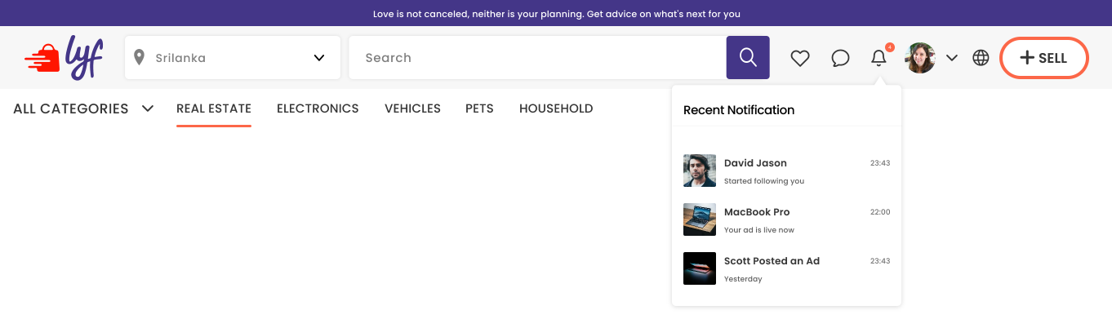

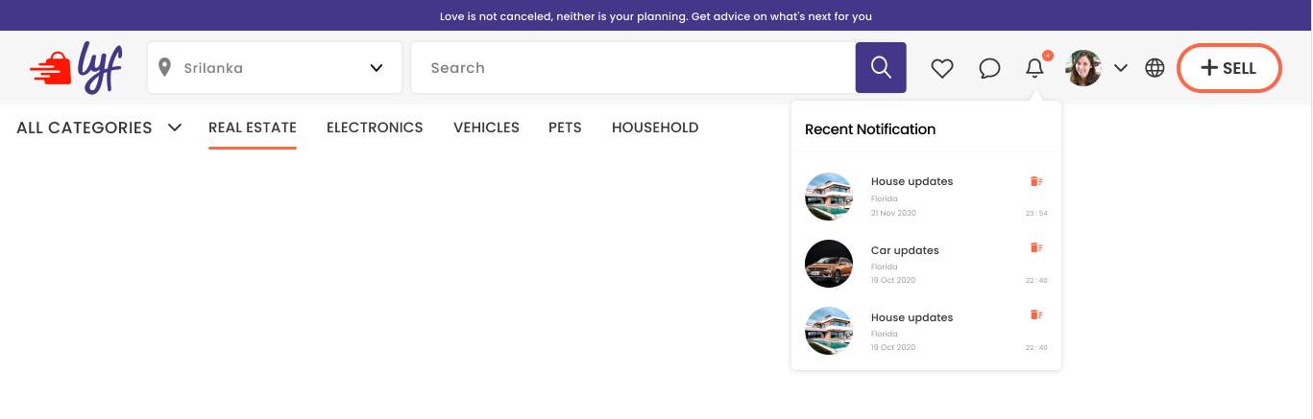

8. a dropdown must be added next to the profile icon in navbar (after login) - > see the above two images

9. when click the profile icon there must be more than 3 options (like manage ads/dark mode/)

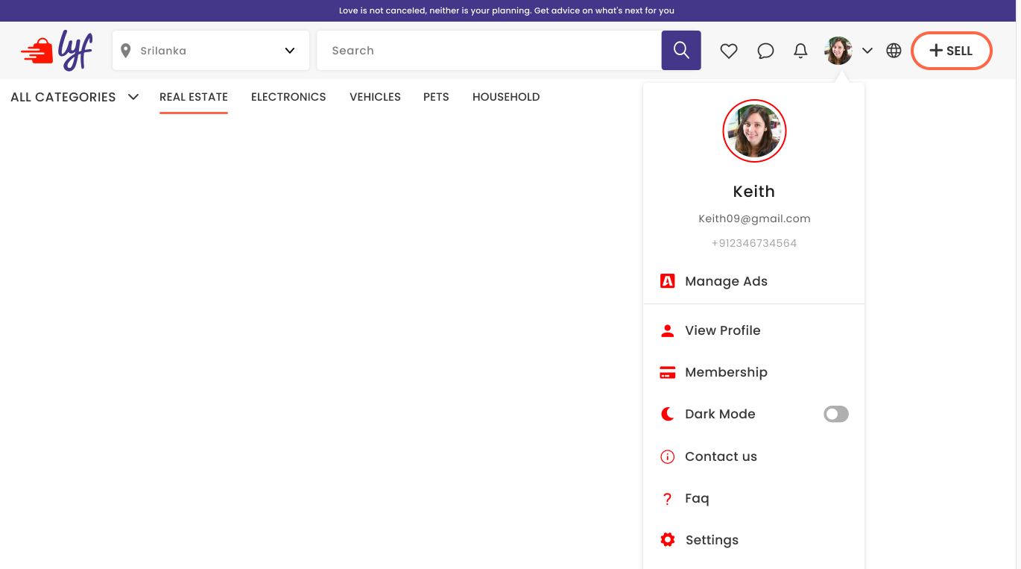

10. when click the sell icon it must display a modal, not like a page

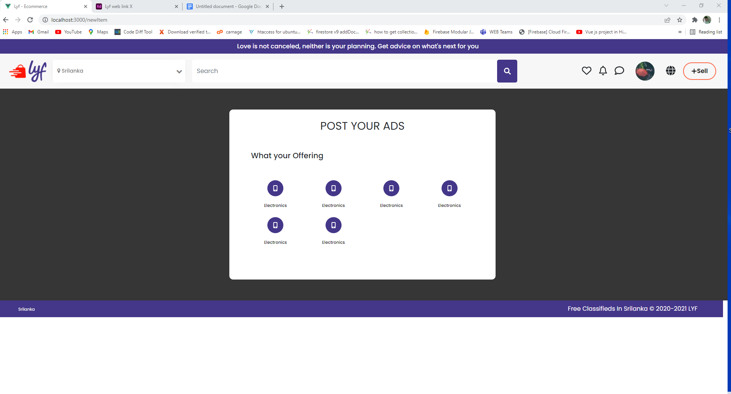

11. ads posting view -> input feilds issue

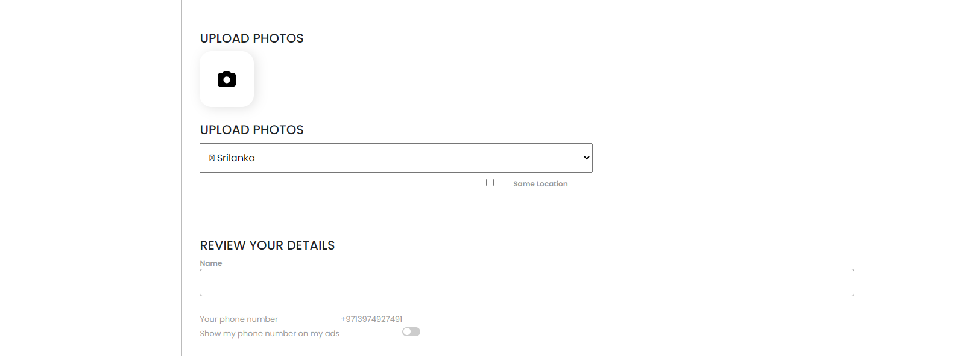

12. user settings page -> styles are not fixed

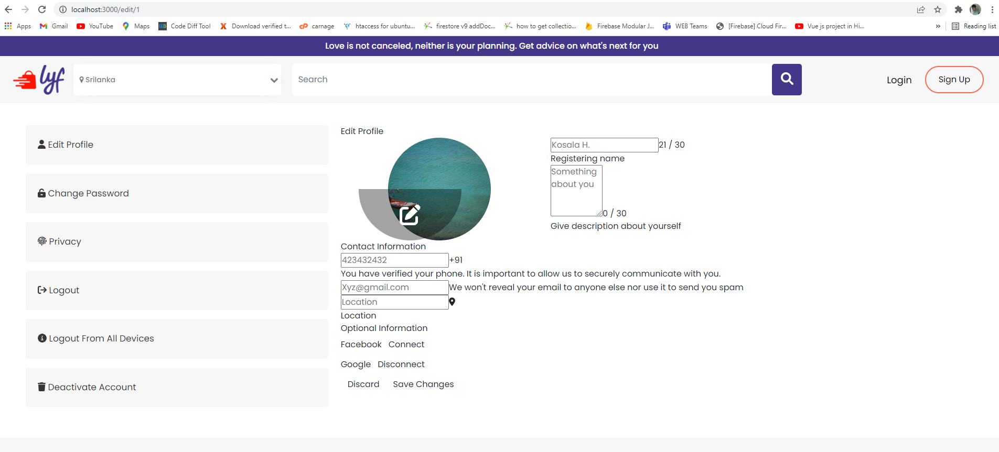

13. pages are not linked

14. chat page -> input feild (send message feild) border

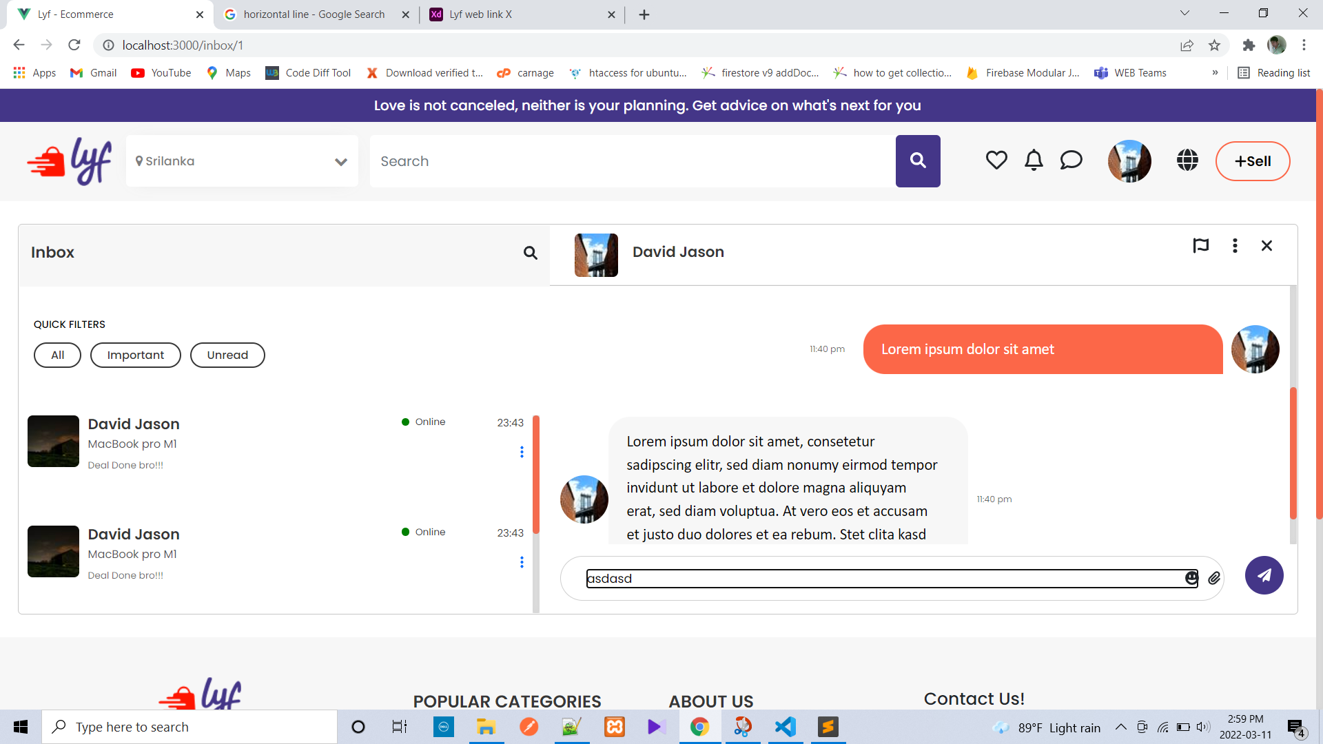

15. post a review text feild in single item view page

